 |  | Office of Prospective Health/Biological Safety  REGISTRATION FOR THE USE OF PLANTS  Version 2/16/15  NOTE: This registration is project/biohazardous agent-specific. Use of a new/different agent, manipulation, or research protocol will require submission of a new registration.

Biological Safety Registration #: (assigned by Biological Safety) Date approved:
Principle Investigator: |  |  |  |  |  |  |  |  | Date:
Department: |  |  |  |  |  |  |  |  | Phone:
Laboratory Location(s): |  |  |  |  |  |  |  |  | Building:
Renewal: |  |  | Yes No |  |  |  | If yes, approval dates: Are there any changes? Yes No

****Please attach a summary of changes from previous registration and highlight the changes in this current registration.*****

I. PROJECT TITLE / AGENTS (Principal Investigator, please complete pages 1-8)

Project Title:
- What materials or agents will be used? (Check all that apply)?:
 | Recombinant DNA or RNA use, genetic recombinant techniques, complete molecules, or organisms (If checked complete Appendix A) |  | Infectious Agents; bacteria, viruses, fungal, prions, etc.
 | Transgenic organisms, animals?  (Complete Appendix A) |  | Biotoxins, allergens or other Biohazardous  Material
Viral or host systems Vectors (specify )
Complete Appendix A
Work with live plants (i.e., genetic modification
of plants or challenge of plants with
recombinant DNA – modified organisms to
include microbes and arthropods) complete
Appendix A.

B. Is this agent/vector/material potentially infectious or hazardous to humans? Yes No

If yes, by what exposure routes? Injection Ingestion Contact Inhalation

C. Is this agent/vector/material a potential hazard to the environment, agriculture, wildlife, or other plants or animals?
Yes No

D. Will this work use a Select Agent as defined in Biosafety Manual or CDC web site (most up-to-date)?
Yes No

E. Status of Project: Contingent on funding, notification date Contingent on other (specify)

Will begin, date Ongoing Materials or agents ordered Yes No

II. PROTOCOL

A. Provide a brief overview or “lay abstract” of the proposed research containing sufficient information to ensure adequate review of the protocol by the East Carolina University Biological Safety Program, and determination of compliance with State, and Federal Regulations. We are interested in the materials and the physical manipulations performed in the lab and potential hazards, (What is used? Where? How is it handled?) not with the theoretical basis of the work. Insert Abstract:

  - What is the purpose of the research?

  - What techniques, manipulations or handling of infectious agents, or human tissue, or recombinant genetic materials will be performed?
Plants – including rDNA hosts
    - Species:
    - Presence of rDNA transposable elements:
    - Mode of reproduction: asexual, open pollination, self—pollination, apomixes:
    - Potential for release of pollen in the work area:
    - Is the plant a common cause of pollinosis, contact dermatitis, or other effects?
    - Genetically modified traits being evaluated:
    - Environmental invasiveness/weediness of plant:

  - What is the source of the biological agent, select agent, or recombinant genetic material, organisms or molecules? How will this material be obtained by your lab?

  - Where will work be conducted? Building/Rooms(s)
List
If more than one room or lab is used, what material is used at each room/lab? (Specify transfer methods and containment if biohazardous material is moved between rooms)

  - Will plant pathogens and symbiotes be used/generated? Yes No
    - Insect Nematode Fungal Bacterial Viral
    - Pertinent information:
    - Was/were the agent(s) acquired under USDA-APHIS permit? If so, please list associated permit numbers

  - Will infectious or biohazardous material and waste be generated? Yes No
If yes, how will it be treated or inactivated before disposal?

Physical containment level requested based on Biosafety in Microbiological and Biomedical Laboratories 5th Edition 2009 and/or the NIH 2013 Guidelines for Research Involving Recombinant DNA Molecules:. Consult Biological Safety manual or web site for more information (http://www.ecu.edu/cs-dhs/prospectivehealth/Biological-Safety-Office-of-Prospective-Health.cfm). Appendix B summarizes the 2007 BMBL basics.

Plant Biosafety Level: BSL-1P BSL-2P

- Containment
  - Biological
    - For Plants
Transgenic in non-propagative plant part
Harvest before sexual maturity
Male sterile lines
Time flowering so pollen not affect compatible neighbors, e.g. inter season
No cross-fertile plant in disposal range
Other (describe):

    - For Microbes
Avoid aerosol when inoculate
Eliminate insect vectors
Obligate host only
Genetically doable organism
Treat run-off water
Control contact by distance/separation
Control contact by season
Other (describe):

    - For Insects
Specify

  - Physical containment
Growth Chamber
Growth Room
Sticky mats
Plastic sheeting
Cover or remove seed heads
Greenhouse room with requisite screening/barriers
Plastic trays under growing plants
Other (describe):

  - Will a Biological Safety Cabinet be used? Yes No

- What personal protective equipment will be used during your work?

Gloves Aprons
Gowns, disposable Shoe Covers
Lab Coats* Surgical Face Mask and/or Face Shield**
Eye Shield or Goggles** Other:

*Lab Coats will not be worn outside of the lab if used as protective apparel; laundering will be provided

The NIH Guidelines specify practices for constructing and handling recombinant DNA or RNA molecules, organisms or viruses containing recombinant molecules, including transgenic plants and animal and knock-out/-in animals and plants. NIH defines Recombinant DNA molecules BROADLY to include molecules constructed outside living cells creation of natural or synthetic DNA segments or molecules, or use of host-vector systems, synthetic genomics or other genetic techniques. The NIH Guidelines apply to all research conducted at ECU regardless of funding source. See full NIH Guidelines on our web site and applicable categories in appendix to this form.

E. Will this work involve recombinant DNA or recombinant genetic techniques as broadly defined by NIH? Yes No

If Yes: Complete the questions below AND Appendix A

- Does this project involve the deliberate transfer of a drug resistance trait to microorganisms that are not known to acquire the trait naturally? (NIH Section III-A) Yes No

- Does this project involve the deliberate formation of recombinant DNA containing genes for the biosynthesis of toxin molecules lethal for vertebrates at an LD50 of less than 100 nanograms per kilogram body weight kilogram body weight? (NIH Section III-B) Yes No

- Does this project involve experiments using Risk Croup 2, Risk Group 3, or Risk Group 4 agents (bacteria, virus, or lower eukaryote)? (NIH Section III-D) Yes No

- Does this project involve the formation of Recombinant DNA molecules containing no more than two-thirds of the Genome of any Eukaryotic Virus? (NIH Section III-E) Yes No

- Does this project involve experiments using whole animals in which the animal's genome has been altered by stable introduction of recombinant DNA into the germ-line (transgenic animals)? Yes No

6. Does this project involve experiments involving viable recombinant DNA-modified microorganisms tested on whole animals at BSL-2 or higher? (NIH Section III-D) Yes No

7. Does this project involve experiments to genetically engineer plants by recombinant DNA methods, or to use plants together with microorganisms or insects containing recombinant DNA? Yes No

8. Does this project involve experiments involving more than 10 liters of culture? (NIH Section III-D)
Yes No

9. “Experiments of Concern” "Recent concerns about bioterrorism and potential dual use technologies have prompted the federal government to identify seven classes of experiments with potential for misuse. Does any of your research fall under one of the following categories?" Would the recombinant DNA work:

a. Demonstrate how to render a vaccine ineffective? Yes No

b. Confer resistance to therapeutically useful antibiotic or antiviral agent? Yes No

c. Enhance the virulence of a pathogen or render a non-pathogen virulent? Yes No

d. Increase transmissibility of a pathogen? Yes No

e. Alter (to expand) the host range of a pathogen? Yes No

f. Enable the evasion of diagnostic/detection modalities? Yes No

g. Enable the weaponization of a biological agent or toxin? Yes No

III. TRAINING DOCUMENTATION

A. Principal Investigator Training and Experience: Please describe your past training and experience in performing the research procedure described in you proposal:

List below all individuals who will be exposed to or handle biohazardous agents in your work:
Have the individuals listed been trained and demonstrated proficiency on use of the agents and procedure-specific** laboratory safety practices and containment procedures and precautions for the Biosafety level requested? Agent and Procedure Specific Training is to be provided by the Principal Investigator, and should be documented in laboratory records and summarized below.

Short term students and professional visitors to the laboratory should not be exposed to biohazardous agents until they are trained in the laboratory procedures and familiarized with the safety plan of the laboratory. Non-essential visitors and minor children should not be allowed access to a laboratory or perform procedures which may expose them to infectious, or biohazardous agents.

Blood Borne Pathogens Training is required for all personnel handling human blood, body fluids, unfixed tissues or human cell lines (including short-term students and visitors). Immunization against Hepatitis B must be offered. (Bloodborne Pathogen Training provides a general overview of BL-2 precautions and is highly recommended for all work at BSL-2 or higher but must be supplemented with laboratory specific training.)

 | Name |  | Position | Agent and Procedure Specific Training completed and documented by PI to date |  | Faculty | Staff | Graduate | Under-grad
1. |  |  |  |  | Yes Date No
2. |  |  |  |  | Yes Date No
3. |  |  |  |  | Yes Date No
4. |  |  |  |  | Yes Date No
5. |  |  |  |  | Yes Date No
6. |  |  |  |  | Yes Date No
7. |  |  |  |  | Yes Date No
8. |  |  |  |  | Yes Date No
9. |  |  |  |  | Yes Date No
10. |  |  |  |  | Yes Date No

IV. Laboratory Safety Plan
Sections A and B together constitute your laboratory Biosafety Manual. This manual should be maintained and accessible in your laboratory. It will be reviewed during Biological Safety inspections.

Section A. General guidelines (Check all that apply to customize for your project)
BioSafety Registration Form Updated 10/26/09
1. |  |  | The entry door to the lab will be posted with the Biohazard Symbol, Biosafety Level, Agent, and Contact Information. BL-1 and above.
2. |  |  | Specimens will be placed in biohazard labeled, well-constructed containers during, handling, processing, and storage Sturdy leak proof closable secondary containers are used for transport or shipping to prevent leakage or spillage. Appropriate precautions will be used for transfers within or between buildings, using common hallways.
3. |  |  | Disposable lab gown for dedicated use in plant growth chamber or greenhouse, not removed from chamber or greenhouse, or autoclaved before removed. Protective clothing will be removed before leaving the laboratory, and stored in an area where it will not be a source of contamination for other people or their belongings. Required at BSL-2P, recommended at BSL-1P.
4. |  |  | Water-resistant lab coats will be used if splashes of infectious fluids are anticipated. Masks and protective eyewear will be worn if mucous-membrane contact with blood or potentially infectious/biohazardous materials is anticipated. Protective clothing will be removed before leaving the laboratory, and stored in an area where it will not be a source of contamination for other people or their belongings. Recommended at BL-1/Required at BL-2.
5. |  |  | Single-use, disposable gloves will be worn at all times when handling specimen or agent. Hands will be washed with a disinfectant soap after removing gloves or immediately if hand is contaminated. Gloves will be removed when exiting the lab and not worn in common areas outside the laboratory. Recommended at BL-1/Required at BL-2.
6. |  |  | Pipetting or suctioning by mouth is forbidden. Pipetting performed to minimize aerosol creation. BL-1 and above.
7. |  |  | Eating, drinking, smoking, applying cosmetics or lip balm, or handling contact lenses is prohibited in the work area. No food or drinks will be stored in areas where potentially infected materials are present. BL-1 and above.
8. |  |  | The Principle Investigator will establish policies and procedures so that persons will be fully trained about the potential hazards and meet all specific entry requirements (training, vaccination, etc.) before entering the lab or beginning work. BL-1P and above. (PI may delegate training, but still is responsible that it occurs).
9. |  |  | All workers and students will be instructed by the PI or designee regarding the Biosafety procedures required for the agent used and manipulation performed. Training will be provided by PI prior to work and proficiency documented. Biosafety Training slides are available on the Prospective Health web site for the use of the Principal Investigator. BL-2 and above.
10. |  |  | All transgenic seeds clearly identified and labeled, and stored in a locked cabinet preferably in a designated room or other confined space. BSL-1P and higher.
11. |  |  | White paper on lab bench with tray to identify and contain stray Transgenic seeds. Required for BSL-2P; recommended for BSL-1P.
12. |  |  | Daily use of Swiffer® or other means (specify broom/vacuum/other ) to remove loose seeds from floor. BSL-2P (use HEPA filtered vacuum for pollen; recommended for BSL-1P.
13. |  |  | Work surfaces and/or equipment will be decontaminated with approved disinfectant after completing work or at least daily, or after a splash or spill event. Large spills should be cleaned up before applying disinfectant to a surface. Appropriate personal protective equipment will be used during cleanup (BL-1 and above).  SPECIFY disinfectant(s) to be used: Dispatch (hypochlorite) Bleach Solution (specify concentration): 1.10 or 1:100 Clidox Other  (If your disinfectant is not listed above, please attach information about its active ingredients and manufacturer’s recommended contact time here for committee review.)
14. |  |  | All concentrated cultures or stocks of biohazardous material will be decontaminated with an EPA approved disinfectant, (BL-1) or will be autoclaved prior to disposal in biohazardous waste containers. Contaminated re-usable equipment or heavily contaminated waste will be decontaminated or autoclaved before disposal. (BL-2 and above).
15. |  |  | All research plant materials be inactivated or devitalized before disposal in the Biohazard waste stream. Specify means: autoclave/steam/heat/other:
16. |  |  | Procedure for Biological Spill: (Mark one)
Spill involving a microorganism or material requiring BSL 1 containment:
- Sweep up all loose biomass for appropriate disposal
- Wear disposable gloves.
- Use paper towels with or without detergent or soap solution to wipe up the visible spill
- Clean spill area with fresh towels soaked in disinfectant allowing contact time per manufacturer’s instructions and then collect. (10% bleach may inactivate pollen)
- Place towels in biohazard bag for disposal.
Spill involving a microorganism or material requiring BSL 2 containment:
- Alert people in immediate area of spill.
- Put on additional protective equipment - if needed to protect shoes, face eyes, etc.
- Cover spill with paper towels or other absorbent materials to stem its flow.
- Avoid splashing.
- Use paper towels with or without detergent or soap solution to wipe up the visible spill.
- Allow a 20-min contact period if using prepared 1 in 10 dilution of household bleach or follow manufacturer’s directions for contact time if a commercial product is used.
- Clean spill area with fresh towels soaked in disinfectant.
- Place towels in a red biohazard bag. Decontaminate waste in an autoclave if heavily contaminated.
Section B. Lab-Specific/Procedures. (Please attach any lab specific SOP’s here or copies of AUP procedure which may help us understand your work.)

1. I have attached an additional separate sheet(s) with my procedure SOP(s).
2. Centrifuge procedure from page 45 and 118 – 121 of the Biosafety Manual will be copied and used,
http://www.ecu.edu/cs-dhs/prospectivehealth/Biological-Safety-Office-of-Prospective-Health.cfm
Without modification
With the following modifications:
Lab-specific centrifuge SOP attached.
3. Biological Safety Cabinet SOP from Biological Safety manual pages 40 – 45 and 93 – 100 will be copied and used,
http://www.ecu.edu/cs-dhs/prospectivehealth/Biological-Safety-Office-of-Prospective-Health.cfm
Without modification
With the following modifications:
Lab-specific Biological Safety Cabinet SOP attached.
4. Autoclave SOP from Biological Safety manual page 47 – 50 will be copied and used,
http://www.ecu.edu/cs-dhs/prospectivehealth/Biological-Safety-Office-of-Prospective-Health.cfm
Without modification
With the following modifications:
Lab-specific autoclave SOP attached.
 | As the Principle Investigator, I shall abide by the ECU Biological Safety Policy and this Laboratory Safety Plan. I will communicate this information to and enforce these practices with all workers and students under my direction And ensure that all personnel under my direction will participate in the Occupational Health Program as indicated. I agree to be responsible for the safe conduct of all personnel under my direct supervision.
 | I understand that the East Carolina University Biological Safety Committee will review this registration form, and will approve or assign the Biological Safety Level to this project. I will notify the Office of Prospective Health/Biological Safety in writing of any changes in the information contained on this registration form; e.g. personnel changes, lab changes, new procedures. Addition of a new organism or biohazard may require submission of a new registration.
 | Signed: |  |  |  |  |  |  | Date:
 |  |  |  |  |  |  | Principal Investigator
Please email a copy of this word document to
Yvonne Taylor (taylory@ecu.edu), Office of Prospective Health. Type in your name on the signature line; signature will be obtained after approval is complete.

To be Completed by the Office of Prospective Health / Biological Safety

Biological Safety Level for this Project (see guidelines in Appendix Table 2):

BSL-1 Plant
BSL-2 Plant

Select Agent? Yes No

If yes, specify____________________________________________________________________________

Biosafety Hazard:
Infectious Agent Human Blood, Tissue, Cells
Biotoxin Transformed Cells
Allergen Tumor Cells
Transgenic Plant Transgenic Plant-associated organism
Exotic plant Other

Laboratory Inspected? Yes No
If yes, date inspected
Satisfactory Unsatisfactory

Biological Safety Committee Chair Approval: |  | Signed: |  |  | Date:
 |  |  | Biological Safety Committee Chair
Biological Safety Registration #: |  | Signed: |  |  | Date:
 |  |  | Biological Safety Officer

Appendix A
rDNA Registration Form
See page 21 for details of NIH Classification system
1. | The proposed experiments with recombinant DNA molecules are (check one):
 | Exempt under the NIH Guidelines  (NIH Section III-F) |  | Non-Exempt according to the NIH Guideline  (See attached Appendix NIH categories III-A, III-B, III-C, III-D, III-E descriptions)

2. | If you checked “Exempt” in question 1, indicate under which criteria the experiments are exempt by marking the unshaded boxes.
 | a. |  | The experiments involve rDNA molecules that are not in organisms or viruses (Section III-F-1 of the NIH Guidelines).
 | b. |  | The experiments involve rDNA molecules that consist entirely of DNA segments from a single nonchromosomal or viral DNA source, though one or more of the segments may be a synthetic equivalent (Section III-F-2 of the NIH Guidelines).
 | c. |  | The experiments involve rDNA molecules that consist entirely of DNA from a prokaryotic host including its indigenous plasmids or viruses when propagated only in that host (or a closely related strain of the same species), or when transferred to another host by well established physiological means (Section II-F-3 of the NIH Guidelines).
 | d. |  | The experiments involve rDNA molecules that consist entirely of DNA from an eukaryotic host including its chloroplasts, mitochondria, or plasmids (but excluding viruses) when propagated only in that host (or a closely related strain of the same species) (Section III-F-4 of the NIH Guidelines).
 | e. |  | The experiments involve rDNA molecules that consist entirely of DNA segments from different species that exchange DNA by known physiological processes, though one or more of the segments may be a synthetic equivalent (Section III-F-5 of the NIH Guidelines).
 | f. |  | The experiments involve rDNA molecules that do not present a significant risk to health or the environment as determined by the NIH Director (Section III-F-6 of the NIH Guidelines).
 |  | f-1 |  | Recombinant DNA in Tissue Culture. Experiments involve rDNA molecules containing less than one-half of any eukaryotic viral genome (all viruses from a single family being considered identical), that are propagated and maintained in cells in tissue culture (Appendix C-I-A of the NIH Guidelines).
 |  | f-2 |  | Escherichia coli K-12 Host-Vector Systems. Experiments which use E. coli K-12 host-vector systems, with the exception of those experiments listed in Appendix C-II-A of the NIH Guidelines, are exempt provided that: (i) the E. coli host does not contain conjugation proficient plasmids or generalized transducing phages; or (ii) lambda or lambdoid or Ff bacteriophages or non-conjugative plasmids shall be used as vectors. Experiments involving the insertion into E. coli K-12 of DNA from prokaryotes that exchange genetic information with E. coli may be performed with any E. coli K-12 vector (e.g., conjugative plasmid).
 |  | f-3 |  | Saccharomyces Host-Vector Systems. Experiments involving Saccharomyces cerevisiae and Saccharomyces uvarum host-vector systems are exempt from the NIH Guidelines, with the exception of experiments listed in Appendix C-III-A,
 |  | f-4 |  | Bacillus subtilis or Bacillus licheniformis Host-Vector Systems. Any asporogenic Bacillus subtilis or asporogenic Bacillus licheniformis strain which does not revert to a sporeformer with a frequency greater than 10⁻⁷ may be used for cloning DNA with the exception of those experiments listed in Appendix C-IV-A of the NIH Guidelines.
 |  | f-5 |  | Extrachromosomal Elements of Gram Positive Organisms Recombinant DNA molecules derived entirely from extrachromosomal elements of the organisms listed in Appendix C-V of the NIH Guidelines (including shuttle vectors constructed from vectors described in Appendix C), propagated and maintained in organisms listed in those Guidelines are exempt.
 |  | f-6 |  | Purchase or Transfer of Transgenic Rodents. The purchase or transfer of transgenic rodents for experiments requiring Biosafety Level 1 (BSL1) containment are exempt. (Appendix GIII- M of the NIH Guidelines).
* If you checked “Exempt” in Question 1, skip the remainder of Appendix A-1. If the research will be performed using Biosafety Level 2 or Biosafety Level 3 containment, complete Appendices A-2, A-3, or A-4 as appropriate.
* If you checked “Non-Exempt” in Question 1, answer the remaining questions of Appendix A-1 as appropriate.
SECTION A
Biosafety Information

3. | Indicate the risk groups (or class) of all material(s) used in the recombinant DNA experiments in this project by marking the un-shaded box.
 | Risk Group 1 | Agents are Not associated with disease in healthy adult humans.
 | Risk Group 2 | Agents are associated with human disease that is rarely serious.  There are often preventive or therapeutic interventions available.
 | Risk Group 3 | Agents are associated with serious or lethal human disease for which preventive or therapeutic interventions MAY be available.
 | Risk Group 4 | Agents are likely to cause serious or lethal human disease for which preventive or therapeutic interventions are NOT USUALLY available.

4. | Indicate the biosafety level(s) at which the recombinant DNA work will be performed for this project.
 | BSL-1 | Low risk agents (generally risk group 1), special containment equipment not required  - Laboratory access should be restricted when experimental work is in progress.  - Work is done on open bench tops.  - Standard microbiological practices are observed.  - Biohazard signs must be posted.
 | BSL-2 | Moderate risk agents (generally risk group 2), biosafety cabinets, restrictions to research areas. All BSL-1 containment and practices plus the following:  - Laboratory access should be restricted when experimental work is in progress.  - Personnel have specific training in handling of agents.  - Biological safety cabinets (BSC) or other physical containment devices are used for potential aerosol generation procedures.  - Biohazard signs must be posted.  - Specific PPE (personnel protective equipment) and entrance requirements.
 | BSL-3 | High risk agents (generally risk group 3), BSL-3 containment facilities, and practices. All BSL-2 containment and practices plus the following:  - Laboratory access is restricted.  - Personnel have specific training in handling of agents.  - All procedures are performed in biological safety cabinets (BSC).  - Biohazard signs must be posted.  - Written safety policies provided by the investigator defining laboratory procedures, waste disposal, disinfection and medical surveillance.  - Centrifuge safety cups must be used.  - Specific facility design parameters must be followed, including requirements for location, ventilation, room integrity and security.  - Written entry logs maintained.

5. | Is the highest proposed Biosafety Level lower than the risk group classification for any of the described agents? (e.g. Use of a single gene from a risk group 3 organism may qualify for work at BL-1 or BL-2). Answer Yes or No in the box below. If “Yes, explain the rationale for the use of the lower Biosafety Level.

6. | Describe the potential biosafety risks of this research proposal. Address the following:  Whether agent(s) may be infectious to humans.  The risks of accidental exposure to personnel.  Whether there is potential for airborne transmission of agent(s).  Precautions to be taken by personnel including any personal protective equipment and/or routine monitoring.  Disposal of agent(s). Describe the specific methods of disposal or inactivation of the agent(s) or contaminated/infectious material(s).

7. | Describe the Principal Investigator’s experience with all vectors, viruses, organisms, or recombinant DNA materials described in this application

SECTION B

Vectors, Hosts, and rDNA Agents: (Maybe NIH Section III-A, III-C, III-D or III-E)

8. | List all Plasmid and Phage Vectors Used:

9. | List inserted DNA used. Include the species from which the insert is derived and what gene product is expressed. If no inserts are used, state “None.”

10. | List known oncogenes, or inserts from above that have oncogenic properties. If none are used, state “None.”

11. | List host organisms for foreign DNA sequences (e.g. E. coli, S. cerevisiae, fungi, mammalian cells or cell lines). Give any pertinent details.

12. | List any oligonucleotides used to manipulate gene function (e.g. siRNA) or as adjuvants (e.g. CpG-containing DNA) either in cell culture or in vivo. If none are used, state “None.”

13. | Are toxins to be expressed and released as part of this research? Answer Yes or No in the box below. If “Yes,” describe the toxic product(s) (including the LD₅₀) that could be produced or released and the containment precautions to be used.

14. | Is there any potential for increased virulence with insertion of DNA into the vector or organism? Answer Yes or No in the box below. If “Yes,” explain in detail.

SECTION C

Viruses and virus Vectors: Maybe NIH Section III-C, III-D, III-E

15. | Does this project involve the use of viruses or viral vectors?  - If “No,” skip questions 16-26, and go directly to Section D (question 27).  - If the Virus or viral vector is a lentivirus (e.g. FIV, HIV, SIV, etc) complete questions 16 and 21-26.  - For all other Viruses or viral vectors, complete questions 16-20.
 | Yes
 | No

16. | List viruses and/or viral vectors used:  Specify the virus family and/or subfamily (e.g. herpesvirus, oncogenic retrovirus, adenovirus, adeno-associated virus, etc).  State the species of origin for each virus or vector used.

17. | Is the virus/viral vector able to enter or infect human cells?
 | Yes
 | No
 | If “Yes”, indicate whether it is a productive or limited infection, and state whether infection can cause disease.

18. | Is a helper virus used in this project?
 | Yes
 | No
 | If “Yes”, describe the helper virus used.

19. | Is the virus/viral vector replication-defective?
 | Yes
 | No
If “No”, skip questions 20-26, and go directly to Section D; question 27 (unless also using Lentivirus/Lentiviral Vectors).
If “Yes”, describe the deletions rendering it defective and complete question 20.

20. | Has the preparation of replication-defective vectors been tested for the presence of replication competent virus?
 | Yes
 | No
If “Yes”, provide details of the assay used.
If “No”, what is the likelihood of conversion to replication-competent virus?

22. | Is the lentivirus/lentiviral vector obtained from a commercial source?
 | Yes
 | No
If “Yes”, provide the name of the commercial source.
If “No”, If “No”, provide the source of the lentivirus/lentiviral vector (e.g. the name of the institution or individual supplying the material).

23. | Is the lentivirus/lentiviral vector generated from a multi-component system? (e.g. separate plasmids for packaging, envelope and gene transfer)
 | Yes
 | No
 | If “Yes”, describe the system used.

24. | Is the lentivirus/lentiviral vector pseudotyped (e.g. expressing a different envelope gene)?
 | Yes
 | No
 | If “Yes”, provide whether the pseudotyping alters the host and cell tropism.

25. | Is the lentivirus/lentiviral vector replication-defective? Answer Yes or No in the box below.
 | Yes
 | No
If “Yes”, describe the deletions rendering it defective and complete question 26.
If “No”, skip to Section D (Question 27).

26. | Has the preparation of replication-defective vector been tested for the presence of replication-competent virus?
 | Yes
 | No
If “Yes”, provide details of the assay used.
“No”, what is the likelihood of conversion to replication-competent virus?

SECTION D

Plants

27. | Will transgenic plants or plant-associated micro organisms/small animals be used or created? (Section III-D or III-E)
 | Yes
 | No

28. | Is the plant or associated micro flora a noxious weed? (III-2-B)
 | Yes
 | No

29. | Can the plant interbreed with noxious weeds in the immediate geographic area? (III-E-2b)
 | Yes
 | No

30. | Can the plant or associated micro flora spread in the environment?
 | Yes
 | No

31. | Does the introduced DNA represent the complete genome if a non-exotic infectious agent?
 | Yes
 | No

32. | Could the transgenic plant or associated organisms impact the environment?
 | Yes
 | No
Would the impact be:
minimal?
more than minimal, but _________ managed?
Other

33. | Does the work involve exotic plants (or exotic infectious agents or micro flora) capable of causing serious environmental harm?
 | Yes
 | No

34. | Could the recombinant material reconstitute the genome of an infectious agent in planta?
 | Yes
 | No

Appendix B

SUMMARY OF RECOMMENDED BIOSAFETY LEVELS FOR INFECTIOUS AGENTS

Biosafety  Level | Agents | Practices | Safety Equipment  (Primary Barriers) | Facilities  (Secondary Barriers)
1 | Not known to  consistently cause  disease in healthy adults | Standard Microbiological Practices | None required | Open bench top sink required
2 | Associated with human  disease, hazard =  percutaneous injury,  ingestion, mucous  membrane exposure | BSL-1 practice plus:  • Limited access  • Biohazard warning signs  • “Sharps” precautions  • Biosafety manual defining any  needed waste  decontamination or medical  surveillance policies | Primary barriers = Class I or II BSCs or other physical containment devices used for all manipulations of agents that cause splashes or aerosols of infectious materials; PPEs*: laboratory coats; gloves; face protection as needed | BSL-1 plus:  Autoclave available
3 | Indigenous or exotic agents with potential for aerosol transmission; disease may have serious or lethal consequences | BSL-2 practice plus:  • Controlled access  • Decontamination of all waste  • Decontamination of lab clothing  before laundering  • Baseline serum | Primary barriers = Class I or II BCSs or other physical containment devices used for all open manipulations of agents;  PPEs*: protective lab clothing; gloves; respiratory protection as needed | BSL-2 plus:  • Physical separation from  access corridors  • Self-closing, double-door  access  • Exhausted air not  recirculated  • Negative airflow into  laboratory
4 | Dangerous/exotic agents which pose high risk of life-threatening disease, aerosol-transmitted lab infections; or related agents with unknown risk of transmission | BSL-3 practices plus:  • Clothing change before  entering  • Shower on exit  • All material decontaminated on  exit from facility | Primary barriers = All procedures conducted in Class III BSCs or  Class I or II BSCs in combination with full-body, air-supplied, positive pressure personnel suit | BSL-3 plus:  • Separate building or  isolated zone  • Dedicated supply and  exhaust, vacuum, and  decon systems  • Other requirements  outlined in the text

*PPE-Personal Protective Equipment
Classification Summary Page for NIH Guidelines

Section III-A: Experiments that require Institutional Biosafety Committee (IBC) approval, Recombinant DNA Advisory
Committee (RAC) review, and NIH Director approval before initiation of experiments.
Deliberate transfer of a drug resistance trait to microorganisms that are not known to acquire the trait naturally, if such
acquisition could compromise the use of the drug to control disease agents in humans, veterinary medicine or agriculture.

Section III-B: Experiments that require NIH/OBA and IBC approval before initiation.
Deliberate formation of rDNA containing genes for the biosynthesis of toxin molecules lethal for vertebrates at an LD50 of
less than 100 nanograms per kg body weight (e.g., microbial toxins such as tetanus toxin).

Section III-C: Experiments that require IBC and Institutional Review Board (IRB) approvals, and NIH/OBA registration before
initiation.
Experiments involving the deliberate transfer of (1) recombinant DNA or (2) DNA or RNA derived from recombinant DNA
into one or more human subjects.

Section III-D: Experiments that require IBC approval before initiation of experiments.
Experiments involving the introduction of recombinant DNA into Risk Group (RG) 2 or RG3 agents for use in animal
experiments or for modifying cells for use in animal experiments. Examples include gene transfer experiments using viral
vectors including adenoviral vectors, murine retrovirus vectors, or lentiviral vectors. Depending upon the details,
experiments with such agents may be conducted at BL1, BL2, or BL3. Experiments in which DNA from RG-4 agents is
transferred into nonpathogenic prokaryotes or lower eukaryotes may be performed under BL2 containment after
demonstration that only a totally and irreversibly defective fraction of the agent’s genome is present in a given recombinant.

Section III-E: Experiments that require IBC notice simultaneously with initiation.
Experiments involving the formation of rDNA molecules containing no more than 2/3 of the genome of any eukaryotic virus
(All viruses from a single Family being considered identical.)may be propagated and maintained in cells in tissue culture
using BL1 containment. Human cells used as host cells or used for production of viral vectors require BL2 containment. It
must be shown that the cells lack helper virus for the specific Families of defective viruses used. The DNA may contain
fragments of the genome of viruses from more than one Family but each fragment shall be less than two-thirds of a
genome.

Section III-F: Experiments that are exempt from NIH Guidelines. However, registration with the IBC is required or status verified by Biological Safety from Animal use Protocol.
III-D-4-c-1 Experiments involving the generation of transgenic rodents that will require BL1 for subsequent research use or status verified by Biological Safety from Animal Use Protocol.
III-D-4-c-2 The purchase or transfer of transgenic rodents. It is not required to register transgenic animals modified only
by gene knock-outs or status verified by Biological Safety from Animal Use Protocol.
III-F-1 Recombinant DNA molecules that are not in organisms or viruses.
III-F-2 Recombinant DNA molecules that consist entirely of DNA segments from a single nonchromosomal or viral
DNA source, though one or more of the segments may be a synthetic equivalent.
III-F-3 Recombinant DNA molecules that consist entirely of DNA from a prokaryotic host including its indigenous
plasmids or viruses when propagated only in that host (or a closely related strain of the same species), or
when transferred to another host by well established physiological means.
III-F-4 Recombinant DNA molecules that consist entirely of DNA from a eukaryotic host including its chloroplasts,
mitochondria, or plasmids (but excluding viruses) when propagated only in that host (or closely related strain
of the same species).
III-F-5 Recombinant DNA molecules that consist entirely of DNA segments from different species that exchange DNA
by known physiological processes, though one or more of the segments may be a synthetic equivalent. See
Appendix A-I through A-V of the “NIH Guidelines”.
III-F-6 Recombinant DNA experiments that do not present a significant risk to health or the environment as
determined by the NIH Director, RAC and following appropriate notice and opportunity for public comment.
See Appendix C of the NIH Guidelines.
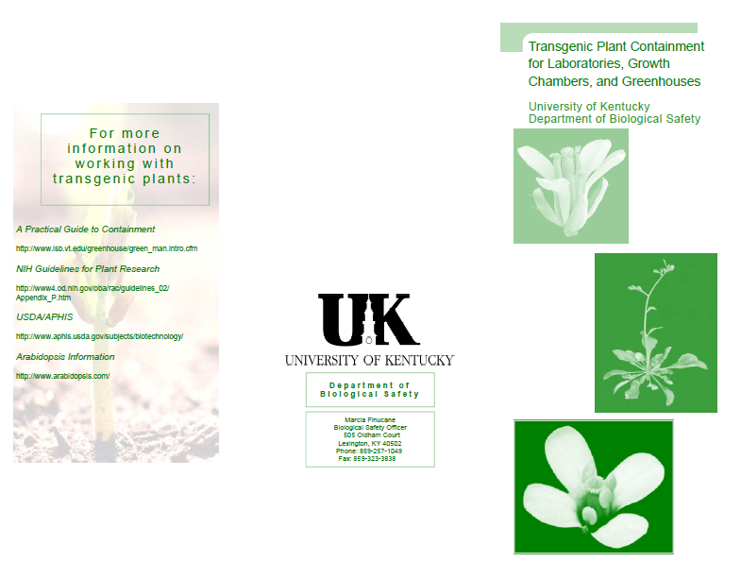
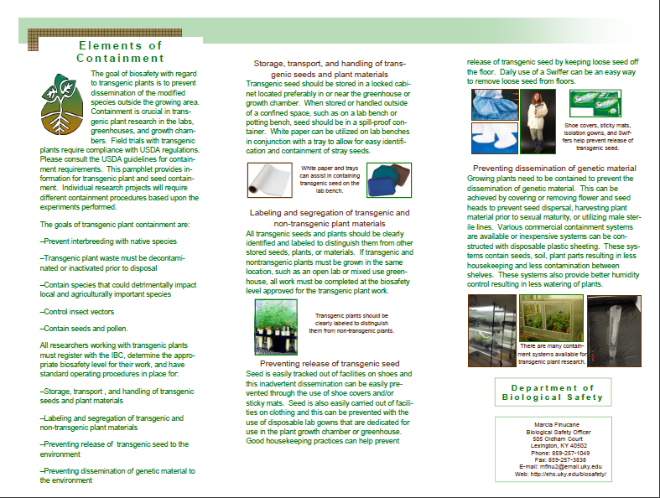

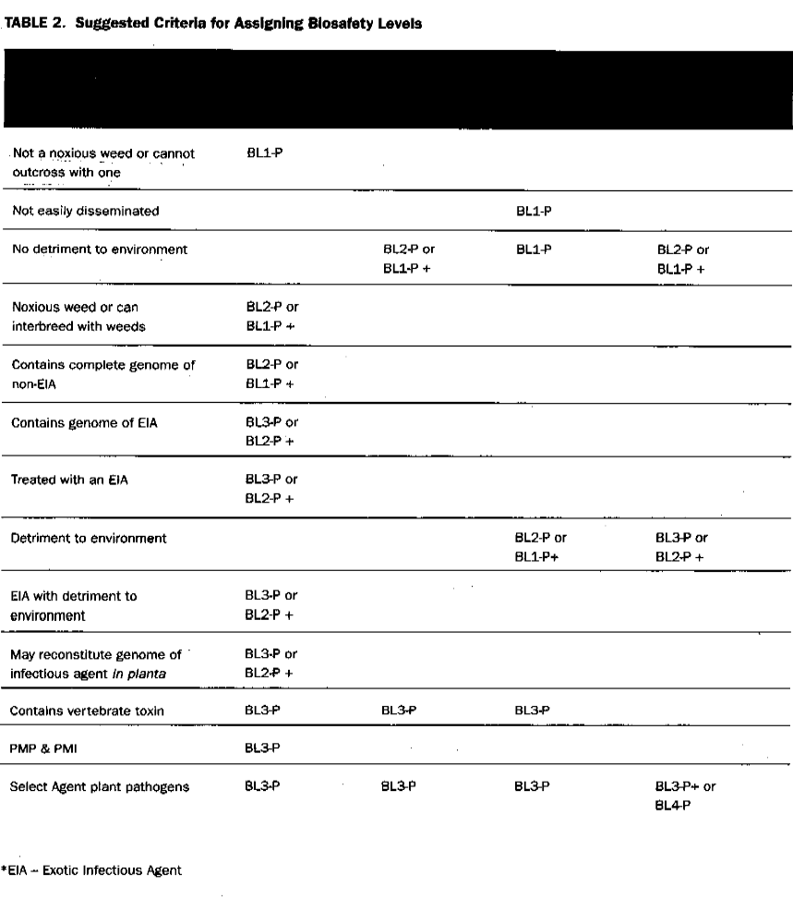

Criteria | Transgenic  Plants | Transgenic  Exotic | Microbus  Non Exotic | Transgenic  Arthropods  and their  Microbes

from “A” Practical Guide to Containment” Adair and Irwin

Criteria Transgenic Plants Transgenic Exotic
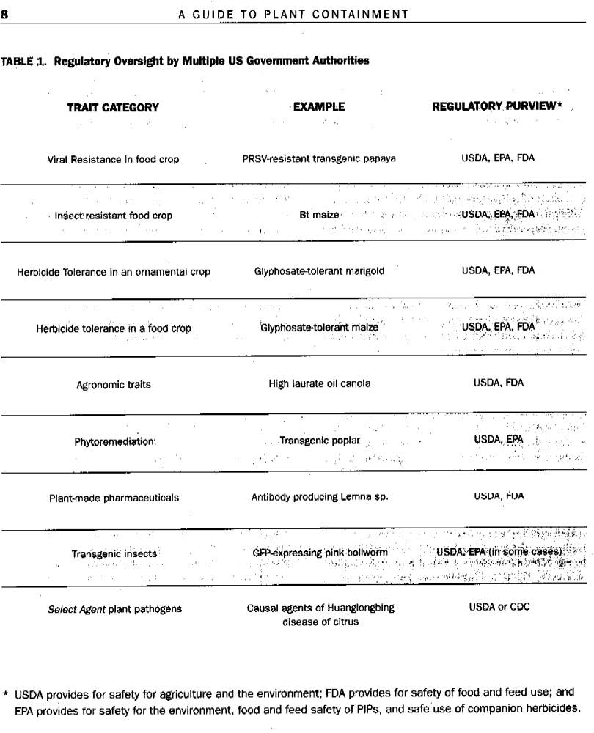from “A” Practical Guide to Containment” Adair and Irwin

